Day Three: Using Python with Jupyter Notebooks

Brief

And we’ve made it to Day Three. You’ll be relieved to know that there’s a lot less reading today and more doing and talking. Our focus is learning how to use a new coding environment, known as a Notebook, and programming in pure Python to analyse our crime rate data. The benefit of using pure Python is that you’ll be able to run the code you write without requiring an ArcGIS license, freeing you up post-University life to continue on your geo-data research career! We’ll also spend some time downloading Python to your personal laptops (if you have one with you), learn more about other geospatial Python libraries you can use and get more familiar with the overall GIS programming ecosystem and other potential languages you might want to pursue for other types of careers other than a data scientist. The idea is that you should get to the point that you’re comfortable experimenting with new code and know where to go learn more. We also want you to get comfortable with another important skill of research - learning how to communicate your results.

What you’ll do today:
- Update and run your script from yesterday to process more data;
- Run the Hotspot Mapping tool from a separate script for all data;
- Learn more about the GIS - Python programming ecosystem;
- Download the Anaconda distribution of Python to your personal laptop
- Use the Jupyter Python notebook environment to analyse our crime rate data
- Within your notebook script, create your own function
- Create maps and a GIF of our crime rate data
- Collate and present your results with your group

Warming Up with Conditional Statements

The first thing we’re going to do today is extend our data processing to another 21 months worth of data. We’re going to add in three months prior to April 2016 to establish a baseline prior to the PSPO legislation being implemented and then extend the analysis up to March 2018. We’re then going to run the hot spot analysis tool on each month, ready to be used in our visual analysis that we’ll be coding up in our Notebook.

Processing 21 more months of data sounds laborious - and if we didn’t have our processing scripted up, running this by hand would probably take us the day and full of making frustrating mistakes. Instead, with a few edits we’ll make next, we’re going to have all this additional data processed within the hour, including generating the hotspot maps!

1. We first need to download our extra data. Our crime data has been downloaded from the data.police.uk website. The interface to download data is extremely simple - have a look and see how you would get the data we now require for analysis.

2. For now, go ahead and generate data for January 2016 - March 2016 for Hampshire Constabulary (we don’t need to include outcome data).

3. Once you’ve downloaded the data, have a look at the folder and files. Do you spot anything different to the data you used yesterday?

4. If you didn’t and had gone ahead with running the code on our datasets, we’d have ended up generating a bug in our workflow. Have a look at the file name if you’ve not spotted the difference.

5. Half way through writing up our bootcamp for you, data.police changed the formatting of their filenames. As a result, getting you to download data directly from data.police would require us to rewrite either all of our code (and instructions) or getting you to rename every single file. As a result, we’re actually going to provide you with a zipfile of the remaining crime datasets. To facilitate this, we wrote a Python script that changed the new file names to our old convention, which you will find in the Rename_files.ipynb file within the notebooks folder in the src folder. This is a Python notebook, which you’ll learn how to open in a little while - so don’t try just yet. But you may find this a useful reference in the future. Dealing with data changes is, as evident, one of the issues that you could face during a research project.

6. Download the remaining datasets from the link provided. Move each dataset folder into the crime_by_month folder to replicate the same folder-file structure as the other six months.

7. We now want to run our code on our new datasets - but before we do so, we need to make an edit to our code, specifically for the CalculateField function.

8. Let’s refresh our memory and take a look at the CalculateField code (see the snippet below).
...

# Add our Crime Rate field to our final shapefile

crime_rate_field = "CR" + year_month_suffix
field_type = "DOUBLE"

arcpy.AddField_management(southampton_lsoas_crime, crime_rate_field, field_type)

print("Field Added")

# Calculate Crime Rate within the Crime Rate field

crime_rate_calculation = "!Join_Count! / !POP_2016!"
expression_type = "PYTHON"

arcpy.CalculateField_management(southampton_lsoas_crime, crime_rate_field, crime_rate_calculation, expression_type)

print("File processing complete")

9. During our calculation, we create the crime rate by dividing the join count by the population of the LSOA. Currently the population denominator within our calculation is set to the POP_2016 column. We need to add flexibility into our calculation so that the POP_2017 column will be used for the datasets in 2017 and, for now, 2018 (the mid-year estimates for 2018 won’t be released until June 2019).

10. To achieve this flexibility, we need to add a few new lines of code to our calculation that use conditional statements.

Using Conditional Statements

We can use conditional statements within our scripts to control or constrain our processing. For example, we might want to only join a certain dataset if it meets a set of requirements.

The most common way to use a conditional statement is to use an if statement. An if statement is really simple to use: basically, if <condition you set> is True, then do this next step of processing.

As a result the syntax is very simple:

if CONDITIONAL STATEMENT:
DO THIS

For example:

if field_type = “DOUBLE”:
print(field_type)

Note two pieces of syntax. First we have a : directly after our conditional statement and then we have an indent for the next line of code, the processing we want to complete if this statement is True.

We can extend our conditional statements using two additional words: else and elif.

The first word allows us to state that if our conditional is false, do this:

if CONDITIONAL STATEMENT:
DO THIS
else:
DO THIS INSTEAD

For example:

if field_type = “DOUBLE”:
print(field_type)

else:
print(“Field is not a double”)

Note the syntax again. Again we have a : directly after our else statement and we have an indent for the next line of code, the processing we want to complete if this statement is False. Note that the else statement is at the same indentation as the if statement.

We can also add an elif statement, which is python’s way of saying, “if the previous condition(s) were not true, then try this condition instead”:

if CONDITIONAL STATEMENT:
DO THIS
elif CONDITIONAL STATEMENT:
DO THIS
else:
DO THIS INSTEAD

For example:

if field_type = “DOUBLE”:
print(field_type)

else:
print(“Field is not a double”)

Within our conditional statements we can use some of the logical operators that we’ve already encountered, for example in our SQL queries (such as and and or), to make slightly more complicated conditions. Note how in Python, these operators are in lower case. In SQL these operators would have been written in uppercase.

The use of conditional statements in for loops is a really common approach in combining processing techniques. For example, in our scenario, it could allow us to only process certain files that meet our requirements. We’ll be using a few of these later today!

11. We want to add a set of conditional statements to our code that changes our calculation to set the denominator, our POP_YYYY field, the YYYY depending on the year of the file.

12. As with any processing, there are multiple ways we could do this - but for now, to keep it as a simple as possible, we’re going to write out three calculations where our conditional statement will tell our code which one to use, depending on the year of the dataset currently being processed.

13. By using conditional logic, we want to state that if our dataset is from 2016, then use this calculation, else if our dataset is from 2017, then use another calculation. We can also add in a statement to help repeat the analysis in the future when the 2018 mid-year population dataset is available. We’ll also add in a final else statement to state there is an unexpected error in our processing - that a suitable year hasn’t be found.

14. To be able to use these conditional statements, we first need retrieve the year of the dataset.

15. From our year_month_suffix, we know we can ‘slice’ our file name to access the year and month in a single string. This time, we just want the year - and not the month. Whilst we could slice the year_month_suffix variable (e.g. year = year_month_suffix[0:5]), it is best practice for us to reference our original variable (crime_table) that generates the year_month_suffix variable, i.e. our dataset name.

17. To get our year string therefore, we need to declare a variable that slices just the year from the file name.

18. If you haven’t already, open up your bootcampprocessing.py script. Once again, as we know this script works (and we don’t want to break it), save it again - but this time as bootcampprocessing_extended.py . Make sure you close down the original script.

19. Within your CalculateField section of code, add in our new slicing variable: year_of_data. Equal this to the appropriate slice of our crime_table variable.

20. Now we have our year, we can get to work adding in our comparison statements. As highlighted a little earlier, the syntax to if statements are very precise - for them to work, you need to make sure you include the right characters and indentation.

21. Our first statement will be for 2016 (it makes sense to work in a chronological order). Directly below our year variable, add in an if statement that asks, if the year variable is equal to the string 2016, then our crime rate calculation variable is equal to the join count divided by the 2016 population column (note, this calculation is the same as we’ve used all along, so you can just cut and paste the existing one over - make sure though you account for the necessary indentation).

22. Our next statement is for 2017. Directly below the first statement, add an else if statement that asks, if the year variable is equal to the string 2017, then our crime rate calculation variable is equal to the join count divided by the 2017 population column.

23. Our next statement is for 2018. Directly below the second statement, add an else if statement that asks, if the year variable is equal to the string 2018, then our crime rate calculation variable is equal to the join count divided by the 2017 population column. (We’ve added this statement in on the just in case basis we want to re-run our analysis in the future and have access to the 2018 population dataset. Here we would add our a POP_2018 column to our Southampton LSOA shapefile in our original step 1 of processing (what you did on Monday afternoon/Tuesday morning) and update the POP_2017 field to reflect our new POP_2018 data. But for now, leave it as 2017).

24. Our final statement is to check for any errors. Directly below the third statement, add an else statement that states, print the string, Error - year not found.

25. And that’s all there is to it. Make sure to save your edited script and run our bootcamp processing extended script on our additional datasets. Any data you generated yesterday will just be overwritten.

26. If you have any issues, just check that you conditional statement code looks like this:

…
# Calculate Crime Rate within the Crime Rate field

year_of_data = crime_table[44:48]

if year_of_data == “2016”:
crime_rate_calculation = "!Join_Count! / !POP_2016!"

elif year_of_data == “2017”:
crime_rate_calculation = "!Join_Count! / !POP_2017!"

elif year_of_data == “2018”:
crime_rate_calculation = "!Join_Count! / !POP_2017!"

else:
print("Error - year not found")

expression_type = "PYTHON"

arcpy.CalculateField_management(southampton_lsoas_crime, crime_rate_field, crime_rate_calculation, expression_type)

print("File processing complete")

26. Before we move on, some of you may also have realised that there would be an even easier way to change our calculation depending on the year of the file - that wouldn’t need to use conditional statements but just variable substitution. Using the year_of_data variable we created, we could rewrite our code as:

...
# Calculate Crime Rate within the Crime Rate field

year_of_data = crime_table[44:48]

crime_rate_calculation = "!Join_Count! / !POP_" + year_of_data + "!"

expression_type = "PYTHON"

arcpy.CalculateField_management(southampton_lsoas_crime, crime_rate_field, crime_rate_calculation, expression_type)

print("File processing complete")

27. But then we wouldn’t have had an opportunity to try out conditional statements. As stated earlier, there are often multiple ways to create the same result. We’d probably prefer to use the latter, as it is fewer lines of code and requires less reading by us to understand and computation from the computer to process.

Getting going with Getis Ord and Hotspot Analysis

28. Now we have our new data processed, we need to produce a hotspot map for each month. To do so, we’ll be using the Hot Spot Analysis (Getis-Ord Gi*) tool. Writing up the script for this tool was one of the Extension Activities provided at the end of yesterday, so some of you may have already have a script that is ready to run. If this is the case, turn to your nearest neighbour who hasn’t got that far and be ready and willing to help them out.

29. For everyone else, here are the same instructions we provided at the end of yesterday. To run the Hot Spot Analysis (Getis-Ord Gi*) tool, you’ll need to:

- Create a new script and save it within your src folder.
- Set the script up following our best practices (remember the import, workspaces, and overwrite statements).
- Decide on which List function is most appropriate to generate our catalogue of processed monthly crime rate data. (Remember we are dealing with listing shapefiles, so whichever function you choose should be capable of listing these types of files).
- Write out our List function, setting it equal to a variable to be used in our for loop.
- Create the opening statement of the for loop that will use the variable storing the output of the list function.
- Within the for loop, run the Getis-Ord-Gi tool (http://desktop.arcgis.com/en/arcmap/10.3/tools/spatial-statistics-toolbox/hot-spot-analysis.htm) on each dataset (using the loop variable as your input) and setting appropriate parameters.
  - With the input field and your output dataset, think about how you can use a slice of the loop variable to generate the right ‘content’.
- Make sure to save your output in an appropriate place - perhaps create a new folder within our processed folder?

This for loop should bring together a lot of the aspects of programming that we’ve been working on over the last two days, so it should feel challenging. But remember to break it down into the small steps above. If you need help, don’t be afraid to ask!

30. Once you’re happy with your script, run it and check a few of your outputs. Once we’ve got our hotspot maps for each month, we’re ready to move onto our analysis.

Please put your green post-it note on your monitor to let us know you’ve got to this point.

Part Eight: The GIS Programming Ecosystem

ArcPy, Python and Jupyter Notebooks are several components of a wider GIS programming ecosystem. Depending on where you see yourself heading in your career, there are many other programming languages and tools to pursue.

Here we outline the different roles and pathways you might consider taking after your degree - and what tools and languages you could follow up with to specialise your skill set within these areas.

Note - the list is not exhaustive, nor would we expect you to want to pursue each of these skills and languages. If you do, good luck! What we can recommend though is to have a look at the descriptions of jobs you’re interested in - not just for now but also in the future - and see how you could build your skill set appropriately.

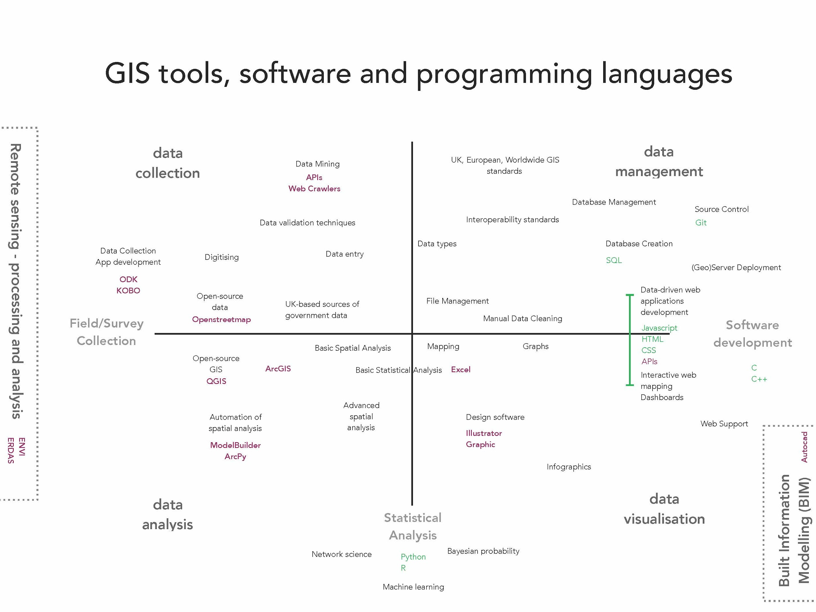

ArcPy to Python: Library and Function finding

We’ve become very familiar with how to use the ArcPy library - and as we’ve found out, it’s relatively simply to use and implement with just a few lines of code and knowing how to use parameters.

However, there is a major drawback with using ArcPy - to be able to use ArcPy, you need to have an Esri ArcGIS license and ArcGIS Desktop installation. For those mac users, this is particularly problematic as you’re unable to install ArcMap on a mac OS. Furthermore, for those on PC, when you move on from University, you’ll lose your education license to use ArcGIS on your own laptop and will need to pay for your own home use license (~£100!).

Increasingly, however, many of the functions provided by ArcPy are written up within and provided by geospatial python libraries that are free and open-source. As a result, it is very much possible to conduct a lot of the processing and analysis that you’ve run in ArcPy in Python - without using ArcPy.

To use these libraries will require a little more work. For all the hundreds of functions we find in the single ArcPy library, we will end up needing to use multiple different libraries to conduct much of the basic GIS processing we ran yesterday. As we stated, each library usually contains functions based around a main focus and as a result, we may find one library useful for analysing table data - but only table data. To added a spatial component, we may end up needing a whole other library. In addition to utilising lots of libraries comes with it understanding all the different parameters (and names of parameters!) that these libraries use. With ArcPy it is relatively straightforward - each parameter was familiar to us because are likely to have used that tool before and know what an Input Feature is or SQL Query - within these libraries, we have to do a little more research to know exactly what the function requires. As a result, we have to become very competent with using the documentation provided by the libraries to understand the functions you’re accessing and their parameters.

To get you started thinking about this, we have two tasks for you to complete over the next half hour - don’t worry if you don’t start or finish the second task, we’ll get to this during the afternoon.

1. Popular Python Geospatial Libraries

Below is a list of popular table data and geospatial data libraries - the majority of which we’ll be using today to analyse our data. Using their documentation, fill in what their main focus is. You might not understand exactly what they do, but this will help provide you with a reference guide for the next task!

Library | Main Focus
pandas
geopandas
numpy
matplotlib
PySAL
shapely
rasterio
fiona
rtree
gdal
pyproj

Rasterstats

This is just a selection of the Python libraries you might come across. Keeping uptodate with all the recent developments and additions can be quite arduous but there are some great lists out there that only take a little googling to find. One recent write-up includes: https://medium.com/@chrieke/essential-geospatial-python-libraries-5d82fcc38731 whilst this users’s github seems to have a pretty exhaustive list of all the current geospatial libraries available - not just for Python but for many other languages: https://github.com/sacridini/Awesome-Geospatial#python .

2. Common ArcPy Functions and their counterparts in Python Libraries

When trying to translate your ArcPy code (or just any ArcMap process or analysis) into Python, the main issue you will come across is trying to find the right function within the right Python library to replicate it. And it really is just a case of research and trial and error.

The first port of call to finding the right function is to search the Internet - look at different documentation, examples and tutorials online. Places such as stackoverflow and gisstackexchange can be invaluable -you’ll often find a lot of people will have the exact same question as you!

When you struggle to find the answer online, the best next place is to ask someone you know who programs, preferably in Python but not necessarily. They may know the answer, or may just know a better way to find the answer!

Your second task is to find an equivalent Python function (and respective Library) for these common ArcPy Functions. We’ll be using a few of these this afternoon, so knowing them in advance will help. You may want to also write out anything you can find about the parameters the function will take - and any other information you might think is useful.

ArcPy Function | Python Library | Function
arcpy.Clip_analysis

arcpy.Buffer_analysis

arcpy.sa.ZonalStatistics

arcpy.SelectLayerByLocation_management

Please put your green post-it note on your monitor again to let us know you’ve got to this point.
Part Nine: An Introduction to Anaconda and the Jupyter Notebooks

So far we used a Python console within ArcGIS and then a standalone Python IDE that came bundled with our ArcGIS installation. Now we want to leave the ArcGIS environment well and truly behind and start programming in pure Python. To do this, we’ll be using something called the Anaconda Distribution of Python.

Usually to install Python on your personal laptop, you would need to download an installation of pure Python (nicknamed CPython) from the Python.org website. Then, you can customise your install as you like - downloading and installing additional libraries and tools that you end up needing - usually from the command line.

The Anaconda Distribution provides us with a shortcut to this - it essentially re-packages CPython and customises it to suit our current needs - enabling the data management, analysis and visualization of large data sets. It is provide by Anaconda (the company) and consists of a sort of ‘suite’ of Python tools and libraries that are tailored towards scientific computing (such as data science, machine learning, predictive analysis).

The Anaconda Distribution works well because it is free and open source, meaning you can download and use it on any computer. It also comes with a very easy to use interface: the Anaconda Navigator, which allows you to launch applications and manage conda packages and environments without using the command-line.

Already we have Anaconda installed on our university machines, so if you don’t have a laptop with you, you’ll be able to continue working on the computer you used to write the code this morning.

For those of you with a laptop, we will spend some time now getting an installation of Anaconda up and running. If you don’t have a laptop, find someone who does so you can follow along.

Installing Anaconda on a laptop

1. To install Anaconda, head to https://www.anaconda.com/distribution/ and choose the right download for your machine. We’ll be using Python 3.7 - and for now choose the graphical installer.

2. Once your download has completed, open it up and follow the instructions to download Anaconda. You’ll probably want to save it in Applications for Macs and in X for Windows laptops.

Exploring Anaconda Navigator

3. To get started, we’re going to use the Anaconda Navigator. Find it within your applications and open. It should look similar to this:
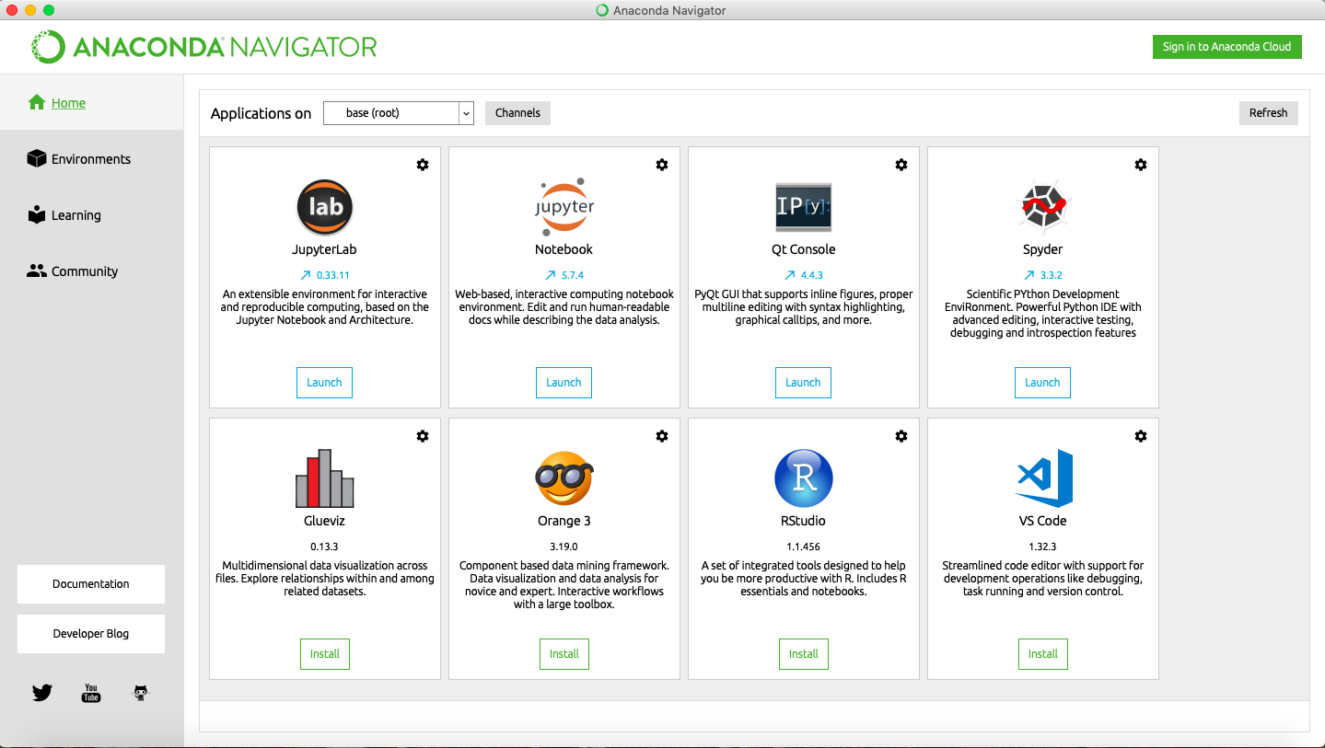

4. As you can see, there are already several tools that you might have already come across, such as Rstudio, as well as others to explore. For example, Spyder is another type of IDE - and one you may prefer to IDLE. You can find out more here: https://www.spyder-ide.org as well as look at YouTube etc. for tutorials on how to use it. Unfortunately we currently do not have time to cover it in the course.

5. If you click on Environments tab, we can now see the different Python environments currently set up within your laptop: usually a base (root) i.e. our main installation, and maybe a few other environments.

6. On the right of our environment are a list of packages (what we’ve been calling libraries) that are either installed or could be installed with this environment.

7. Staying in our base (root) environment for now, type ‘numpy’ into the ‘Search Packages’ box. It should show numpy (as well as a few other libraries) are installed - and gives you a brief description about what it does.

8. Next, type in pandas - and change the dropdown from ‘Installed’ to ‘All’ (if you need to). You should see that geopandas (and a few related libraries are not installed). Check the box on geopandas, click apply and this will install the gdal package. This means we can now import geopandas into our code and use any functions within the package. It may take a minute or two for Anaconda to gather the package. When the package box appears, click on Apply to install the package - again this will take a few minutes.

9. In the meantime, navigate back to the main screen.

Using Jupyter Notebooks

On the main screen, you should see an option for Jupyter Notebook. We will be using this application today!

Previously Notebooks were created solely for use with the Python programming language, but they can now be used for many languages, including R. They are becoming very common in research and data science and you’ll find them increasingly integrated in other programming tools. For example, the Spyder IDE mentioned above can open and run a Notebook within it’s editor.

Another recent development is the through the ArcGIS for Python API, which enables you to access and use ArcGIS functionality within a Notebook. This is far too much for us to cover here, but is another part of the GIS ecosystem that you might consider looking into. A training course is available here: https://www.esri.com/training/catalog/5c7091bd65e21d6e2182f252/get-started-with-arcgis-notebooks/ (Note, it is free until April 13th - if that interests you!).

Today we’ll be running through a pre-written Notebook to get familiar with using the notebook, as well as then editing and writing code within two other notebooks to continue to process and then analyse our Crime Rate data.

10. Click on the Jupyter Notebook option - you should see a browser page load (this is how Notebooks work, within a browser window) that details your file system.

11. Click through to navigate to your src folder within the Bootcamp folder. Click on ‘Intro_to_Notebook.ipynb’. A new browser window will open up.

12. You’ll be using the Notebook in tandem with this Workbook - we want you to work through each step on the computer, but we provided below the appropriate spaces for notes and any of the written tasks.

13. Fill in the table below as instructed by Step 3 in the notebook:

Markdown Formatting Cheat Sheet

Formatting | Markdown Symbol
Bold
Italic
Code
Bullet Points
Headings

Once filled in, return to your Notebook.

Part Ten: Data Analysis in Python within the Notebook Environment

The ability of a Notebook to run code and display simple outputs within the same document has really been embraced by the research community. It allows you to test code quickly whilst also finding out insights about your data incredibly quickly. As you can see from the small amount of code we processed this morning, the Notebook can display tables - but it can also draw graphs and even maps - both of which we want to help analyse our crime data!

But before we can get started with analysis our code, we have to tackle a few more programming concepts that tell us how our data is read in and stored in Python, and how we can use this ‘storage format’ to select and manipulate our data.

Once we’ve got our head around this, we’ll then be using the two remaining ipynbs in your src folder to analyse our data. You’ll need to read them carefully and provide the edits where required.

Our first ipynb, Data_Analysis_Statistics, will also cover the basics of processing table and spatial data using the pandas and geopandas library, as well as how to create a function and using functions from the numpy statistical analysis library.

Our second ipynb, Data_Analysis_Visual, will introduce you to the basics of creating graphs and maps using matplotlib library.

Calculating Crime Rate Statistics using our Notebook

In this first notebook, we will continue to process our datasets as well as use several functions from different Python libraries to structure and perform calculations on our datasets. We want to get you familiar with the process of reading in data, understanding its new structure (and what ‘class’ it is), learn how to process data that is stored in this ‘class’ and then complete simple calculations on our data for our analyses. You’ll then learn how to return our results as a table file (i.e. csv) that can be used in our analysis.

Before any of you begin to worry, the most complicated statistic we will be calculating today is the (arithmetic) mean of our crime rates. Trying to provide adequate background on statistics would probably require a whole other bootcamp - and certainly one not written by us!

1. In the browser that popped up where you accessed the previous notebook (within your src folder → notebooks), open ‘Data_Analysis_Statistics.ipynb’.

2. As you can see, we’ve already got the basic Notebook structured and written for us - what you need to do next, is read through and follow the instructions where applicable. You’ll need to provide some data paths and field names.
Creating maps using our Notebook

In this second notebook, we’ll be using our code to generate a graph of our crime rate data, as well as create maps of both our crime rate and our hotspot data.

This involves generating maps for 27 months of data in ArcGIS would be a nightmare - if you even get that far with the amount of times ArcMap often crashes! What's worse, if you realise you made a mistake - or want to reformat an aspect of your map (for example, change the colours), you'll need to do this another 26 more times, which - as we know - will take a very long time!

Learning how to read in spatial data and then create and export maps is a key skill to using programming with GIS and will be the focus of this notebook. Whilst the maps aren’t quite as pretty as what you could probably provide in ArcMap, it is a good approach to making lots of maps really really quickly. And with new Python libraries popping up all the time (that we haven’t had the chance to explore yet!), it is likely that you’ll be able to produce maps of a similar aesthetic with a little research and resolve!

If you’re running out of time (and we probably are at this stage!), for now you can just run the notebook (this one doesn’t require any input from you) to get our outputs for the analysis. Then come back and read through the notebook to see what we’ve done and how.

1. In the browser that popped up where you accessed the previous notebook (within your src folder → notebooks), open ‘Data_Analysis_Visual.ipynb’.

Part Eleven: Writing Up Our Results

Have the PSPOs been effective in reducing crime in Southampton?

RQ1. How has the crime rate changed in the LSOAs affected by the PSPOs?
RQ2. How has the crime rate changed in the LSOAs not affected by the PSPOs?
RQ3. Is there a significant difference in the crime rates?

Part Twelve: Wrap Up and Reflect

Learn how to use programming in various tools within and without ArcMap
Design a process and research methodology to utilise these tools
Learn how to automate the processing and analysis of data using code.
How to document this automation.
Apply to a real world research project.
Gain confidence in learning new technical skills.
Technically challenging, visually rewarding

What have you learnt over the last three days?

- Programming?
- Developing technical skills?
- Confidence in taking programming and GIS further?

Developing your GIS programming skills - where do I go from here?

Recommended Python courses

CodeAcademy (Free)

https://www.learnpython.org

Recommended Geo-Python courses

https://geo-python.github.io/2018/index.html

Follow on: https://automating-gis-processes.github.io/2018/

Follow on: https://automating-gis-processes.github.io/CSC18/

https://github.com/geopandas/scipy2018-geospatial-data

https://anitagraser.com/pyqgis-101-introduction-to-qgis-python-programming-for-non-programmers/

Data Science orientated

http://darribas.org/gds18/

ESRI training courses

https://www.esri.com/training/catalog/5c7091bd65e21d6e2182f252/get-started-with-arcgis-notebooks/

And many more out there!

Also - come back to this workbook - and particularly the notebooks! - after completing several of the courses and see how much more you may understand! Challenge yourself with the uncompleted Extension Activities.

